1. The title of this paper by Castaneda-Moya et al. 2011 in the previous folder (provided by Blanca) was “Patterns of Root Dynamics in Mangrove Forests Along Environmental Gradients in the Florida Coastal Everglades, USA”, however the reference on the master datasheet was “Castaneda-Moya et al. 2013. "Allocation of biomass and ANPP of mangrove forests along environment Gradients in the FL Everglades, USA". Forest Ecol. And Mgmt. 307”. Need Blanca’s double check.

Response: The PDF in this folder ‘Patterns of Root Dynamics in Mangrove Forests Along Environmental Gradients in the Florida Coastal Everglades, USA’ was confirmed by Blanca.

According to Blanca’s suggestion, we confirmed that ‘Plant Stature’ should be ‘shrub’ if tree height < 5m.

Such information can be found in the page 1180. Therefore, Meng updated the stature to ‘shrub’.

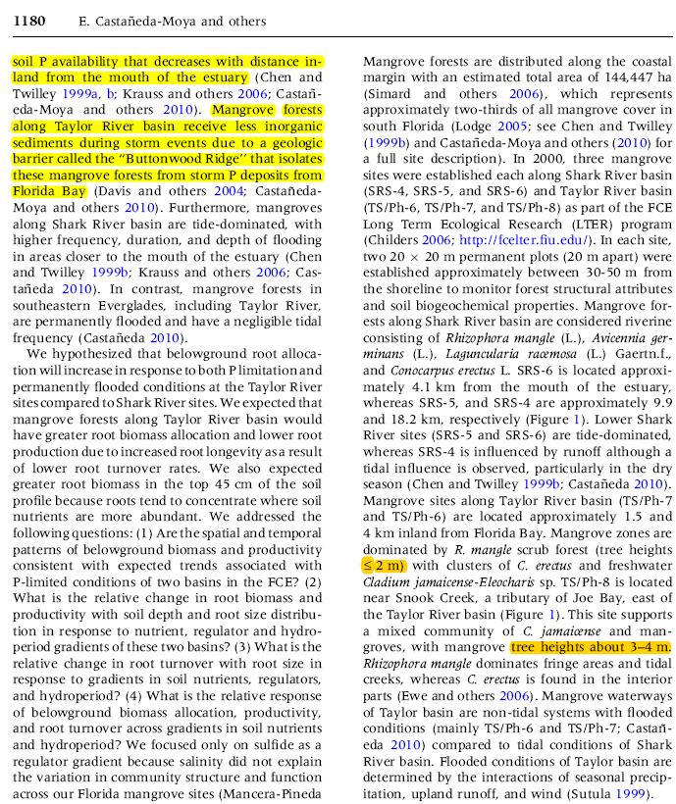

2. The unit for belowground biomass and biomass rate in this paper was g m2 yr, however the unit on the database from Blanca was g Cm2 yr, need Blanca to double check.

*[Response]: After the double-checking, we confirmed that the unit for above and belowground biomass was g m-2 yr-1. Details can be found below.*

3. The aboveground biomass data were from Fig. 5 (Page 1190)

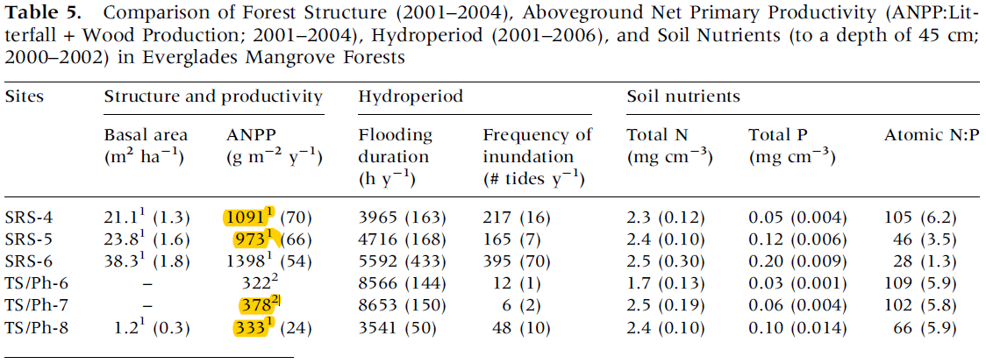

4. The belowground biomass data were from the text on page 1183

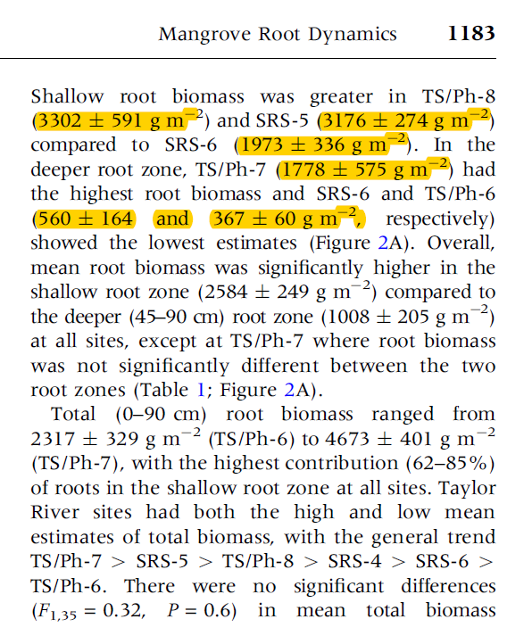

5. The belowground biomass rate data were from the text on page 1186

